
Beautiful
Savior
Lutheran
Church
Newsletter
APRIL 2019
HOW CAN I REACH BEAUTIFUL SAVIOR?
Phone: 480-967-2660; Email: office@beautifulsaviortempe.org or check us out on the WEB: www.beautifulsaviortempe.org
Mail or in person at: 1337 W. 11th St., Tempe, AZ 85281
Church offices are open Monday-Friday 8:30 a.m. – 12:30 p.m.

FELLOWSHIP HOUR SPONSORS sign-up sheet for April is on the bulletin board in the fellowship hall or let Dorothy know which Sunday you can volunteer for: April signups that still need sponsor are: 7, 14, & 28. Please sign-up in the fellowship hall or Call Dorothy at 602-276-7076.
***If you put food in the refrigerators please put your name and the date you put it in on the items!
Thank you, Dorothy

MARK YOUR CALENDARS:


PALM SUNDAY WORSHIP
10 a.m.

EASTER SUNRISE WORSHIP
7 a.m. on the Patio

EASTER FESTIVAL WORSHIP W/HOLY COMMUNION
10 a.m. in the Sanctuary




LWML EASTER BREAKFAST
SUNDAY, APRIL 21
(between 7 a.m. & 10 a.m. services)
Sign-up sheet will be in the narthex
Bring your friends & family

MARCH ATTENDANCE:
Average attendance for Worship Services: 77; Average attendance for Adult Bible Study: 10

Campus Rejuvenation
Fund Status for Council

Campus Rejuvenation Fund Status 25 March 2019
1) Collected $101,721
Approved for projects by voters: $71,000 (Not to Exceed)
Reserved for Community Projects: 10% = ~$10,200
Spent: $0
Committed: $1,938 for 4 replacement microphones. We will receive about $225 back in rebates.
2) Seven projects were approved by the voters on 10 Feb:
Paint inside/outside of church, replace carpet, reupholster pews, replace wireless microphones, seal
the Christ window, fix fellowship hall leak, new sanctuary lights

3) The Voters also approved allowing the Church Council to sign contracts for these specific projects provided each project has 3 bids and is no more than 10% over estimate, there are at least 5
voting members at the meeting, and the total of all contracts does not exceed the authorized NTE.

4) The Trustees have been meeting with painting, lighting, and carpeting contractors to get bids. They will
then work with the CRF committee to mutually evaluate contractors and make selections (Best value
contracts, colors, lighting styles, etc.)

5) The CRF committee has also met and recommended that 4 organizations each receive an equal share of the money reserved for community projects. The organizations are Lutheran Ministry at ASU, Camp ALOMA, LaMesa (a Lutheran organization working to help the homeless population in the East
Valley), and helping to feed Tempe High School Student in need. More information will be made
available at the April 28 Voter's meeting when the Voter's will be asked for their approval.

HIGHLIGHTS OF THE MARCH 2019 COUNCIL MEETINGS
The regular BSLC Council meeting was held March 19th lacking a quorum. A special Council meeting was held March 23rd. Highlights of those meetings are:
- Pastor reported attendance at soup meals and Lenten services has been good.
- Jenna Misch is planning an Easter egg hunt after the Easter Breakfast; volunteers to help are welcome.
- Treasurer reported February expenses and income were almost equal.
- Pastor’s family dental & vision insurance was inadvertently dropped. Reinstatement will cost approximately $200 per month.
- Debbie O’Neill won the Elders chili cookoff event.
- Gideons will be meeting at Beautiful Savior several times in the coming months.
- Stewardship delivered hygiene kits to Gililland and Holdeman schools.
- Trustees are obtaining bids for painting, carpet replacement, and lighting improvements as directed by the Voters Assembly.
- The Braille project (printing and assembling large print volumes for the blind) has moved into the preschool rooms. They meet Tuesday mornings and welcome volunteers.
- Music Director has had sanctuary piano installed on a dolly and plans to have a platform built for the organ.
- Women in Mission prepared a meal for the Lutheran Ministry at ASU students and will be assembling Easter baskets for their Maundy Thursday meal.
- Positive Thinking Committee prepared and served the corned beef and cabbage meal on March 17th. They will decorate the church on the Saturday before Easter.
- Don Schumm presented a proposal for replacing the wireless microphones in the sanctuary; if ordered by March 31, cost will be about $1900; Voters had approved up to $3000 for this project
- Proposal to be presented to Voters for distributing 10% of the Campus Rejuvenation funds to:
  - Lutheran Ministry at ASU
  - Camp ALOMA
  - La Mesa
  - Food assistance at Tempe High

If you are interested in receiving the Council minutes and report packets please contact Sandra Wardwell at 480-334-4176 or s.wardwell@asu.edu

CAMP ALOMA:

Hello from ALOMA! We would like to invite your families to one of our favorite events of the year. Could you please put this in your bulletin for the next 3 Sundays?

Disconnect to Reconnect
Have you ever just wanted to get away? To unplug? Unwind? Have a real conversation with your kids? If you are looking for a place to reconnect with God, your family, or just revitalize your spirit, then ALOMA is here for you! ALOMA is a Christian camp located in the Bradshaw Mountains, just 15 minutes from downtown Prescott. And we are holding our popular Disconnect to Reconnect weekend from April 26th-28th. Breakfast and lunch will be provided as well as a room in one of our cabins. There is also an amazing Easter Egg Hunt in the Forest, and all at no cost! Please call 928-778-1690 or email office@campaloma.com for more information.
Thank you, Leah McKean
Camp ALOMA
BOARD OF FINANCE:



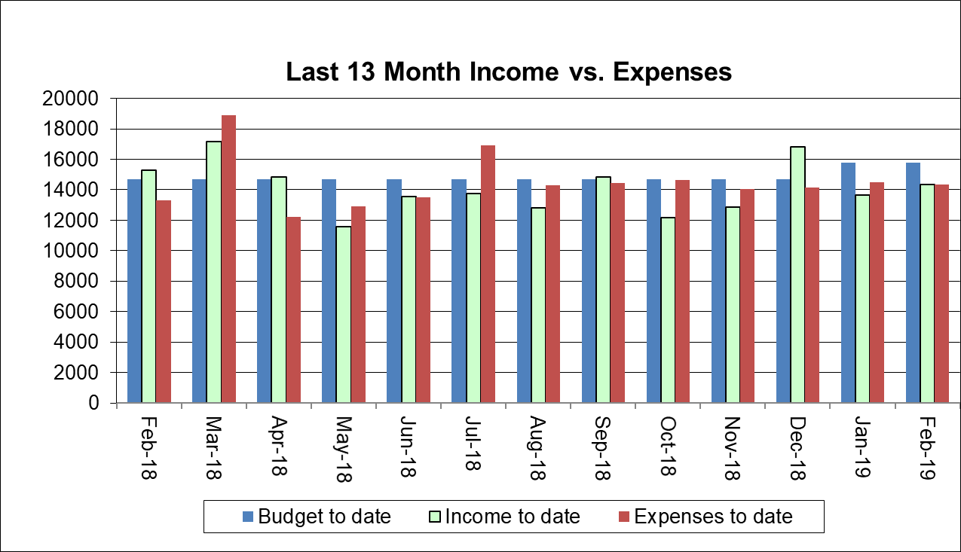

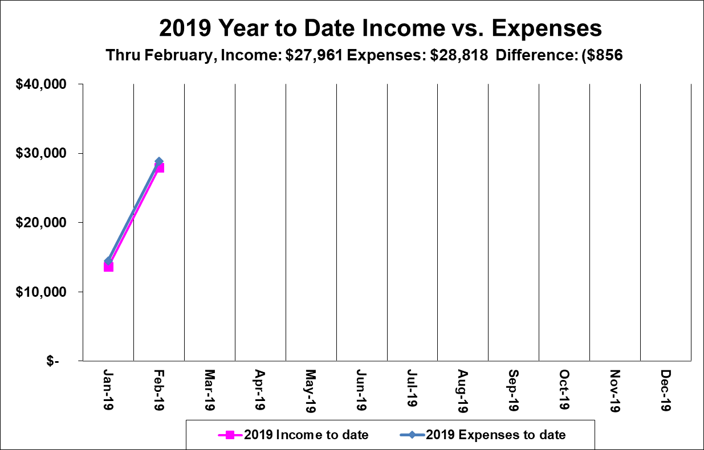
STEWARDSHIP COMMITTEE:
STEWARDSHIP COMMITTEE
April, 2019
Easter is right around the corner, but, without Good Friday, there would be no Easter. We look, then, on the Suffering Servant. We hear again the story of His Passion. We think anew of the ridicule and physical torment He endured even before His walk to Golgotha. We ponder His last words from the cross on which He hung in agony: “’It is finished. ’with that He bowed His head and gave up His spirit,” (John19:30). Focusing on this event in history reminds us again of the great cost Jesus paid for our salvation and leads us to worship and praise Him with all we are and have.
Stewardship Committee continued with our church’s project, Outreach in the Community, by collecting, making up and delivering forty hygiene kits to Gililland Middle School and Holdeman Elementary School. For the Lutheran Ministry at ASU, Stewardship and LWML furnished a meal for students; Sharon Owens, Director of Lutheran Ministry at ASU, has requested from Cap Makers 150 knitted/crocheted caps by the end of the year—the order is nearly fulfilled—Kathryn Odle crocheted 100 caps. Kathryn also crocheted caps for Justa Center to give to the homeless. Bobbie Littou knitted 40 baby caps that Dorothy delivered to Maricopa County Hospital. Charlotte Grefe has joined the Cap Makers and we welcome everyone who likes to knit or crochet. Stewardship will be helping LWML serve an Easter breakfast following Easter Sunrise Service. Anyone wanting to help will not be turned away. We are all faithful stewards of time, talents and treasures that God entrusts to us. Gladys Meyer, Prayer Chain Leader

LWML: WOMEN IN MISSION
 WOMEN IN MISSION (LWML)

The March meeting was attended by nine Beautiful Savior members and one from Holy Cross. We used a Bible Study from the Spring LWML Quarterly as our topic; Nameless Women of the Bible. We thought about the woman in the crowd who called out ‘Blessed is the mother who gave you birth…” and focused on how Jesus used this comment to direct attention to God the Father, not to Himself.
We collected quite a few things from BSLC women for the ASU Easter basket project. We plan to meet on Saturday, April 6th at 9 AM to assess what we have and begin assembling the baskets. We need to have them ready for Sharon Owens for distribution at the Maundy Thursday supper.
We prepared the supper for Sharon’s students on Thursday, Mar. 21, providing a salad bar meal with chips and cookies.

Thank you for your support of LWML!

Please let me know if you have any questions about the LWML and join in our activities whenever you can.

Sandra Wardwell (480-334-4176 or s.wardwell@asu.edu )

LUTHERAN WOMEN’S MISSIONARY LEAGUE (LWML)
SPECIAL EVENT

The Palo Verde/Ocotillo Zone LWML is working with the other Arizona Zones to host a special event on Saturday, April 27th. This is a training event for all Arizona Zones, Societies, Pastors and church leaders called WRAP, ‘Women Ready And Prepared’. It was designed by the National LWML and was presented to our District LWML leaders. The District President and other District leaders will be in Phoenix to present this training.

Zone Event: WRAP Training
When: Saturday, April 27, 11 AM to 3 PM
Where: Christ Church Lutheran, 3901 E. Indian School Rd., Phoenix 85016
Registration: Deadline is April 18th, cost is $15.

Breakout sessions include:
1. S.A.L.T. (Sharing Active Leadership Techniques)
2. Mission Grant Selection & Distribution
3. Engage and Retain Volunteers
4. Reaching Different Cultures & Generations
5. Basic Protocol & Structure
6. Resources — We’ve Got Them!
and a special breakout session just for Pastors

All Beautiful Savior women and their friends are invited to attend! Please contact Sandra Wardwell (480-334-4176 or s.wardwell@asu.edu ) if you are interested!


PASTOR MISCH:

As another month rolls on by, I find that there are a lot of things to complain about. We can complain about the weather. It is getting a little warm isn’t it? We can complain about work. We are always busy and the closer to summer the busier we get. We can complain about politics. Someone in government is doing something we don’t like. If sports is your thing we can easily find something to complain about when it comes to our favorite teams. Life and complaining seem to go hand and hand, but is it good for us to focus our time and effort on complaining? It certainly is easy to do.

There are plenty of legitimate concerns that we can have about this nation and the current cultural context. The renewed push for pro-abortion policies is concerning. The culture’s lack of interest in church is also concerning. And the subjective morality employed by many people young and old will only lead to big problems down the road. These are legitimate concerns but sometimes it feels like our efforts to impact this society go completely unnoticed and that is frustrating.

When we see a problem, we want to fix it. When we see a problem in government, we believe the solution is to get out there and vote. When we see a problem with someone’s behavior, we think the solution is to point out where they are wrong. However, I’m not convinced the solution to fix the nation is to vote for the right people, and I’m not convinced the way to make people act the way we want them to is to hold everyone to our standard of morality. I think the solution to the problems that we face is the gospel, pure and simple. Allow me to explain.

In the time after the nation of Israel was conquered by Babylon the vast majority of people were taken into exile from Jerusalem into Babylon. They were taken from familiarity where expectations and behavior was, for the most part, shared. They were taken from that and thrown into an unfamiliar land, with unfamiliar customs and expectations. The book of Daniel chronicles the lives of a few Israelites in the time of the Babylonian exile and especially Daniel but also the lives of three men, Shadrach, Meshach, and Abednego. These three men were chosen to work in the king’s court and they were given these names as a way to change their identity from Hebrew to Babylonian. Being in a pagan nation put them in a lot of uncomfortable situations, and when faced with the decision to be faithful to God and to reject the worship of an idol they chose to be faithful to God and in so they were sentenced to death. However, God protected them when they were thrown in the fiery furnace and because they were faithful to God the impact of their witness changed the lives of many a Babylon.

It is God who changes hearts and minds. It is not our opinions, it is not our vote. It is the gospel of God. The biggest impact that we can have in a land of exile is to proclaim the gospel no matter what, and allow God to work on the hearts and minds of the people of the nation.

Pastor Misch

